AntennaPod-2992

ID-273

Apk

1.7.1

Bug report description

<https://github.com/AntennaPod/AntennaPod/issues/2992>

**App version:** 1.7.1 commit [d26d212](https://github.com/AntennaPod/AntennaPod/commit/d26d2126072654ba95f31f2bb638479bc2f199c4) (from Google Play)

**Android version**: 8.0.0

**Device model**: Samsung Galaxy S8

**Expected behaviour**:  
The cover and show notes should not disappear when the screen auto-rotates.  
[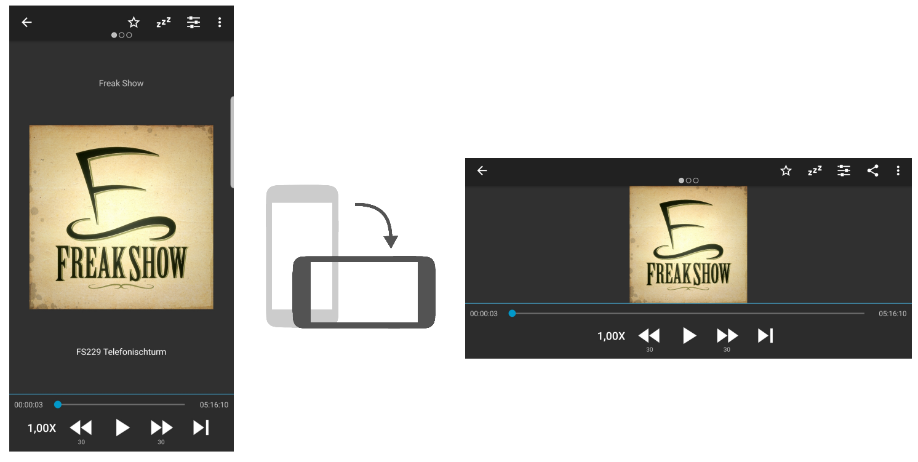](https://user-images.githubusercontent.com/20678151/51264713-6c686000-19b7-11e9-8899-a1294c2a816d.png)

**Current behaviour**:  
The cover and show notes of the playing podcast disappear when I rotate the phone and the screen orientation switches from Portrait to Landscape or vice versa. Only when I go back to the playlist and then reopen the detail page the information will reappear.  
[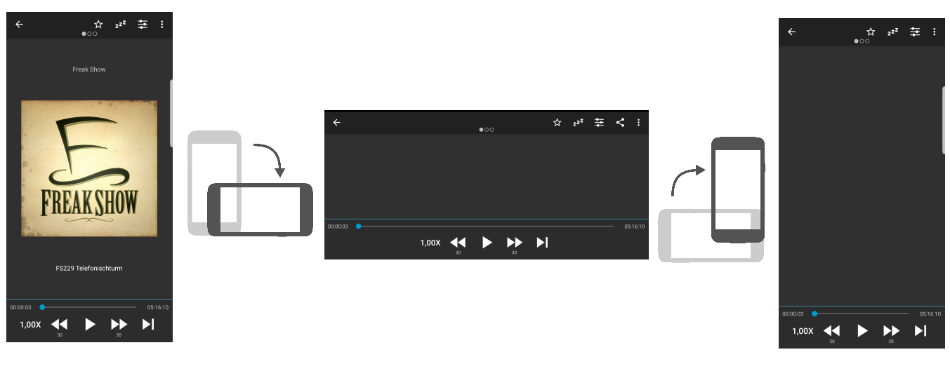](https://user-images.githubusercontent.com/20678151/51264733-7722f500-19b7-11e9-82cc-929d767d5d33.png)

**Steps to reproduce**:

1. Open the detail view of the currently playing podcast
2. Rotate the phone (regardless of switching from Landscape to Portrait or from Portrait to Landscape)
3. Notice that the podcast cover and the show notes are gone

Screen shots sequence

First, download some podcast

The cover of the podcast disappears